EXPERIMENT 27:
After modifying a file in a cloned repository, commit the changes locally and push them to GitHub.
Tasks:
- Clone a repository (from question 1).
- Modify a file (e.g., README.md).
- Stage the changes with git add.
- Commit the changes with git commit -m “Updated README”
- Push the changes to GitHub using git push.
Step 1: Clone the Repository
- Open Git Bash on the local machine.
- Navigate to the location where the repository needs to be stored.
- Clone the GitHub repository using the git clone command.
- Wait for the cloning process to complete successfully.
git clone <repository_url>
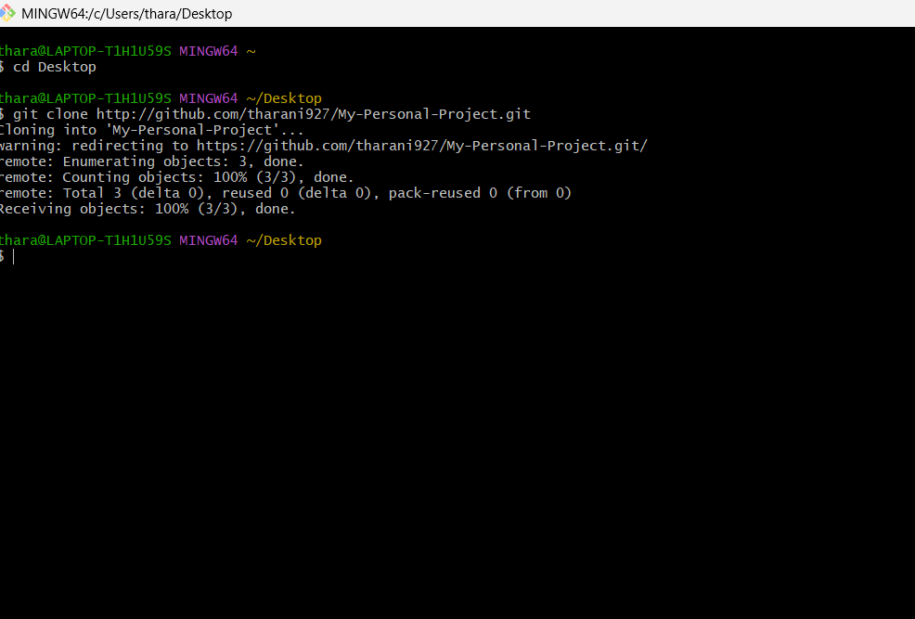
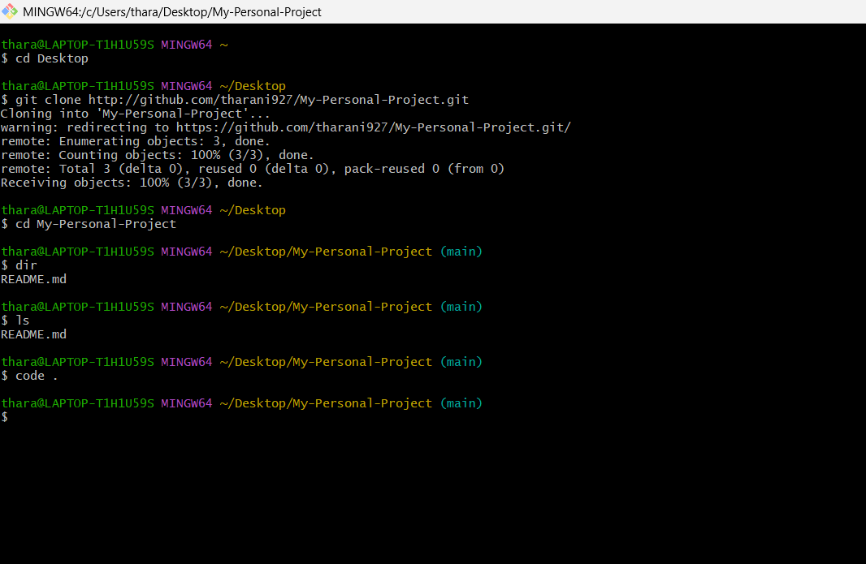
Step 2: Navigate to the Repository
- Move into the cloned repository directory using the cd command.
- List the repository files to verify that the repository was cloned successfully.
cd <repository_name>
ls
Step 4: Open the Repository and Modify the File
- Open the cloned repository in Visual Studio Code or any preferred code editor.
- Locate the file that needs to be modified, such as README.md or any source code file.
code .
- Open the selected file.
- Make a small modification, such as updating a line of text, correcting a spelling mistake, or adding a short description.
- Save the modified file.
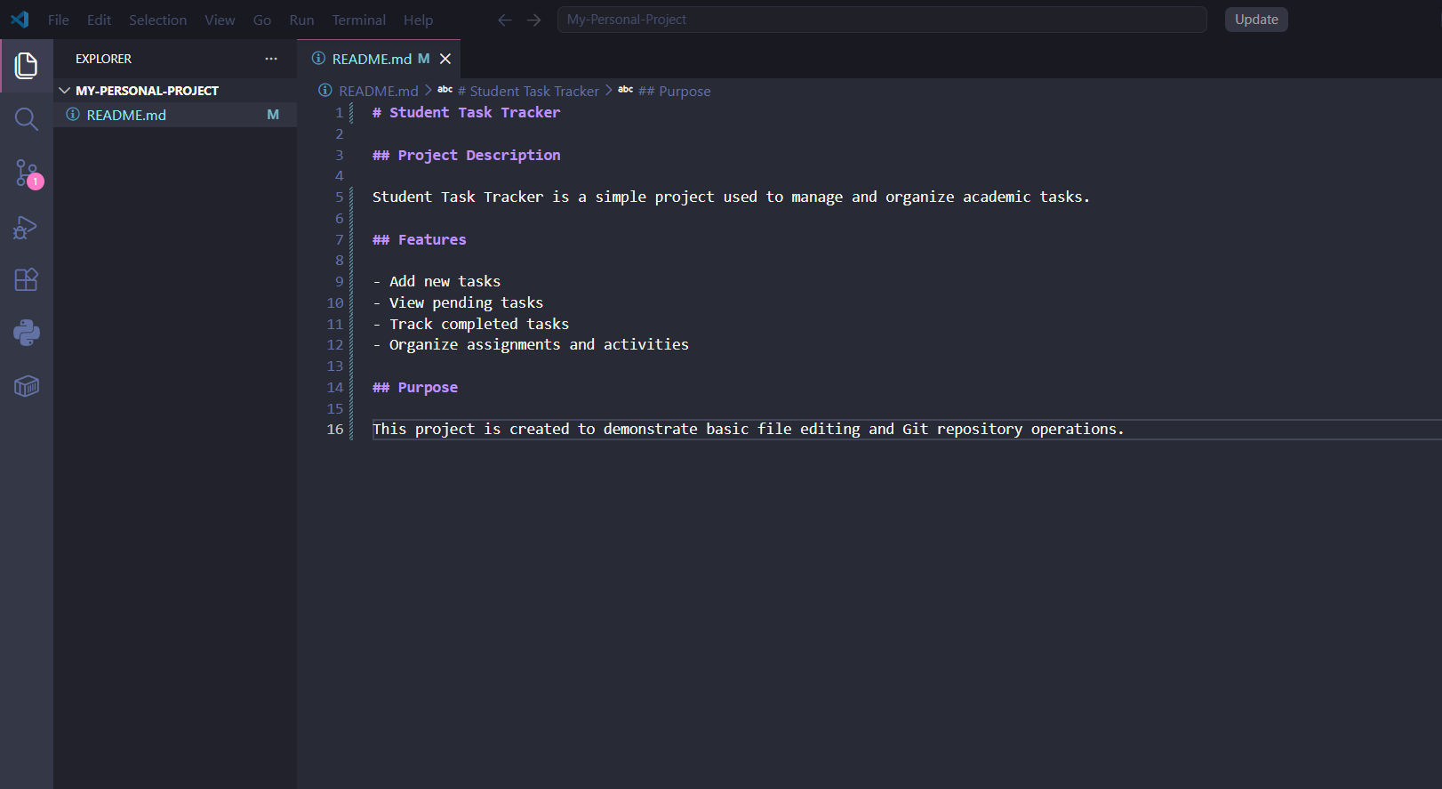
Step 4: Check the Repository Status
- Return to Git Bash.
- Check the status of the repository to identify the modified file.
git status
- Verify that README.md is displayed as a modified file.
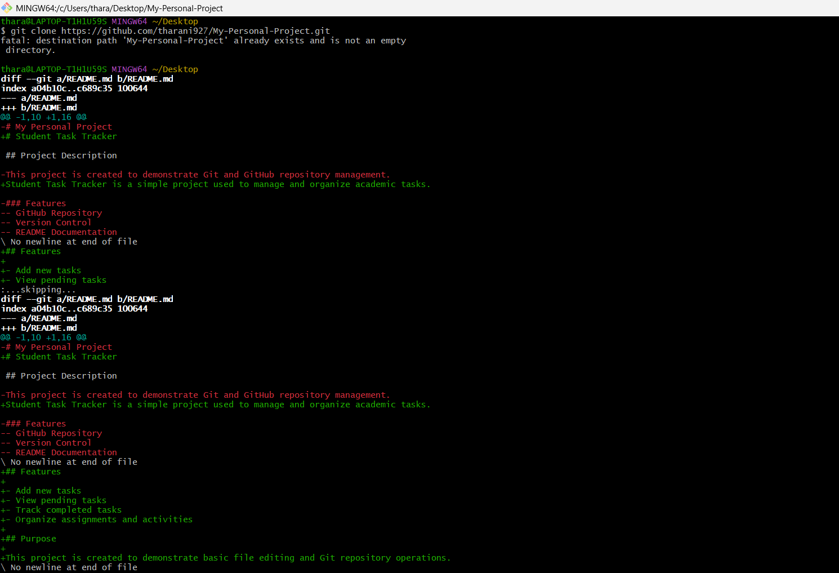
Step 5: Stage the Changes
- Add the modified file to the staging area using git add.
- Verify that the file has been staged successfully.
git add README.md
git status
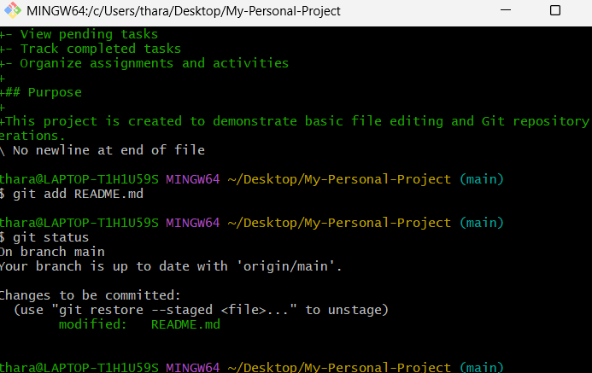
Step 6: Commit the Changes
- Commit the staged changes to the local Git repository.
- Provide a meaningful commit message describing the modification.
git commit -m "Updated README"
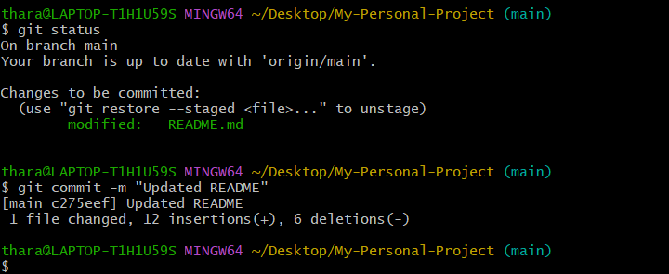
Step 7: Push the Changes to GitHub
- Upload the committed changes from the local repository to the GitHub remote repository using git push.
git push origin main
- Wait for the push operation to complete successfully.
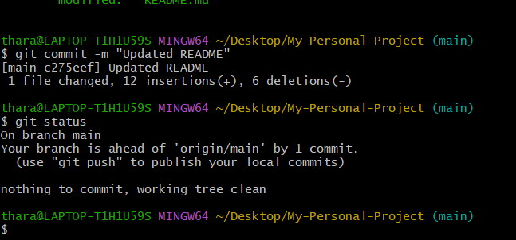
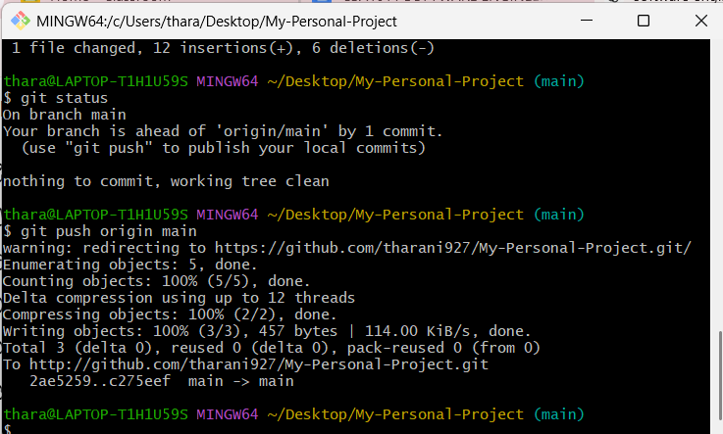

Step 8: Verify the Changes
- Open the GitHub repository in a web browser.
- Refresh the repository page.
- Open README.md and verify that the updated content is displayed.
- Check the commit history to confirm that the new commit has been added successfully.
